38.58: From Eq. (38.13), the speed in the ground state is 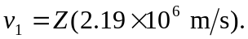 Setting 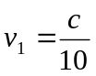 gives Z = 13.7, or 14 as an integer. b) The ionization energy is 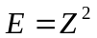 (13.6 eV), and the rest mass energy of an electron is 0.511 MeV, and setting 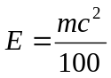 gives Z = 19.4, or 19 as an integer.

